ALLIANCE UNIVERSITY
[Department Name]

PROJECT REPORT
PROJECT 9
OPTIMIZER COMPARISON USING A NEURAL NETWORK
Comparison of SGD and Adam Optimizers Using a Neural Network on the Iris Dataset
Submitted by : Shashank M
Register / Roll Number : [Enter Register / Roll Number]
Department : [Enter Department]
Course / Subject Name : [Enter Course / Subject Name]
Faculty Name : [Enter Faculty Name]
Institution : Alliance University
Academic Year : 2026–2027
Date of Submission : [Enter Date]

CERTIFICATE
ALLIANCE UNIVERSITY
This is to certify that Shashank M, bearing Register / Roll Number [Register Number], a student of [Department Name], Alliance University, has successfully completed the project titled
“Comparison of SGD and Adam Optimizers Using a Neural Network on the Iris Dataset.”
as part of the course [Course / Subject Name] during the academic year 2026–2027. The work presented in this report was carried out by the student under my guidance and supervision. It is an original piece of academic work and has not been submitted elsewhere for the award of any degree or diploma.
The project is found to be satisfactory and meets the academic requirements for submission.
Faculty Guide Head of Department External Examiner
([Name]) ([Name]) ([Name])
Date: [DD/MM/YYYY]
Place: [Place]
DECLARATION
I, Shashank M, hereby declare that the project report titled “Comparison of SGD and Adam Optimizers Using a Neural Network on the Iris Dataset” is a record of original work carried out by me for academic purposes as part of the course [Course / Subject Name] at Alliance University during the academic year 2026–2027.
The work was done using standard, publicly documented tools and libraries, and the sources that I consulted are listed in the References chapter. The results reported here were obtained by running the programs described in this report. I further declare that this report has not been submitted, in full or in part, to any other institution or for any other degree, diploma or award.
Shashank M
Register / Roll Number: [Register Number]
Date: [DD/MM/YYYY]
Place: [Place]
ACKNOWLEDGEMENT
I would like to express my sincere gratitude to my faculty guide, [Faculty Name], for the guidance, encouragement and constructive feedback that helped me to complete this project successfully.
I thank the Head of the Department, [Department Name], and the management of Alliance University for providing the academic environment, laboratory facilities and resources required for this work.
I am also grateful to the developers and maintainers of the open-source tools used in this project (Python, NumPy, Pandas, Matplotlib, scikit-learn and TensorFlow/Keras) and to the creators of the freely available Iris dataset.
Finally, I thank my family and friends for their constant support and motivation throughout the project.
Shashank M
ABSTRACT
This project compares two widely used optimization algorithms, Stochastic Gradient Descent (SGD) and Adam, by training the same small neural network on the Iris dataset. The dataset has 150 flowers of three species described by four measurements, so the task is multiclass classification. A fully connected network with two ReLU hidden layers (16 and 8 neurons) and a Softmax output layer was trained with sparse categorical cross-entropy loss. Both optimizers used the same architecture, initial weights, data split, preprocessing, batch size (16) and number of epochs (100); SGD used a learning rate of 0.01 and Adam used its default of 0.001. Training and validation loss and accuracy were recorded every epoch, and the models were then evaluated on a held-out test set. In this experiment Adam reached lower training loss sooner and obtained 90.00% test accuracy against 83.33% for SGD, while an extra SGD run with learning rate 0.1 reached 93.33%. The test set is small, so repeated runs were also examined. The findings apply only to this dataset and setup. Reported values come from a NumPy implementation equivalent to the Keras code provided.
TABLE OF CONTENTS
CERTIFICATE i
DECLARATION ii
ACKNOWLEDGEMENT iii
ABSTRACT iv
CHAPTER 1 – INTRODUCTION 1
1.1 Background 1
1.2 Problem Statement 1
1.3 Objectives 1
1.4 Scope 1
CHAPTER 2 – THEORETICAL BACKGROUND 3
2.1 Neural Networks 3
2.2 Forward Propagation 3
2.3 Loss Function 3
2.4 Backpropagation 4
2.5 Optimizers 4
2.5.1 Stochastic Gradient Descent (SGD) 4
2.5.2 Adaptive Moment Estimation (Adam) 5
2.6 SGD vs Adam 6
CHAPTER 3 – DATASET 7
3.1 Iris Dataset 7
3.2 Features 7
3.3 Target Variable 7
3.4 Dataset Preparation 7
3.5 Dataset Visualization 8
CHAPTER 4 – NEURAL NETWORK ARCHITECTURE 10
4.1 Model Parameters 10
4.2 Architecture Diagram 11
CHAPTER 5 – METHODOLOGY 12
CHAPTER 6 – PYTHON IMPLEMENTATION 13
6.1 Software Requirements 13
6.2 Import Libraries 13
6.3 Load Iris Dataset 14
6.4 Data Preprocessing 15
6.5 Build Neural Network 16
6.6 Train Using SGD 16
6.7 Train Using Adam 17
6.8 Model Evaluation 17
6.9 Note on How the Reported Results Were Generated 18
CHAPTER 7 – RESULTS AND VISUALIZATION 19
7.1 SGD Training Results 19
7.2 Adam Training Results 19
7.3 Accuracy Comparison 20
7.4 Loss Comparison Graph 21
7.5 Validation Loss Comparison 21
7.6 Accuracy Comparison Graph 22
7.7 Validation Accuracy Comparison 22
CHAPTER 8 – CLASSIFICATION PERFORMANCE 23
8.1 Predictions 23
8.2 Confusion Matrix 24
8.3 Classification Report 25
8.4 Performance Comparison 26
CHAPTER 9 – OPTIMIZER COMPARISON AND ANALYSIS 27
9.1 Training Speed 27
9.2 Loss Behavior 27
9.3 Accuracy Behavior 28
9.4 Test Performance 28
9.5 Convergence Behavior 28
9.6 Learning Rate 28
9.7 Overall Experimental Observations 29
9.8 Supplementary Check: Repeated Runs 29
CHAPTER 10 – HYPERPARAMETER EXPERIMENT 31
10.1 Observations 32
CHAPTER 11 – ADVANTAGES AND LIMITATIONS 33
11.1 SGD Advantages 33
11.2 SGD Limitations 33
11.3 Adam Advantages 33
11.4 Adam Limitations 33
CHAPTER 12 – APPLICATIONS 34
CHAPTER 13 – RESULT 35
CHAPTER 14 – CONCLUSION 36
CHAPTER 15 – FUTURE ENHANCEMENTS 37
CHAPTER 16 – VIVA QUESTIONS AND ANSWERS 38
CHAPTER 17 – REFERENCES 40

CHAPTER 1 – INTRODUCTION

1.1 Background
Machine Learning (ML) is a branch of computer science in which a program learns patterns from data instead of being given explicit rules. For example, rather than writing rules to recognise a flower, we show the computer many measured examples and let it discover the relationship between the measurements and the flower type.
Neural networks are one of the most popular ML models. A neural network is built from simple units called neurons arranged in layers. Each neuron multiplies its inputs by numbers called weights, adds a bias, and passes the result through an activation function. By combining many neurons, a network can represent complicated relationships.
Classification is the task of assigning an input to one of several categories. In this project the input is a set of four flower measurements and the output is one of three Iris species.
Optimization is the process of finding the values of the weights and biases that make the network’s predictions as good as possible. “How good” is measured by a loss function: the smaller the loss, the better the predictions. Training a neural network is therefore an optimization problem: find the parameters that minimise the loss.
A neural network can have thousands or even billions of parameters, so these parameters cannot be found by hand or by a simple formula. An optimization algorithm (optimizer) is needed to adjust the parameters step by step in the direction that reduces the loss. Different optimizers adjust the parameters in different ways, which can change how fast and how smoothly the training proceeds. This project studies two common optimizers, SGD and Adam, on the same problem.

1.2 Problem Statement
Build a simple neural network to classify Iris flowers and compare the training behavior and classification performance of SGD and Adam optimizers.

1.3 Objectives
- Understand basic neural network classification.
- Understand the role of optimizers in neural network training.
- Implement a neural network using the Iris dataset.
- Train the same model using SGD.
- Train the same model using Adam.
- Compare training and validation loss.
- Compare training and validation accuracy.
- Evaluate classification performance on test data.
- Analyze the differences between SGD and Adam.

1.4 Scope
The project focuses on one simple classification problem, the Iris dataset, and on a comparison of two commonly used optimizers, SGD and Adam. A single small network architecture is used throughout. The comparison covers the behaviour of the loss and accuracy during training, the performance on unseen test data, and a small experiment on the learning rate of SGD.
The project does not attempt to decide which optimizer is best in general. Observations made here are specific to this dataset, this architecture and these hyperparameters. Larger datasets, deeper networks and other training settings may behave differently.

CHAPTER 2 – THEORETICAL BACKGROUND

2.1 Neural Networks
A feed-forward neural network passes information in one direction, from the input to the output. The basic building blocks are:
- Input layer: receives the raw feature values. It performs no calculation; it has one node for each feature (4 in this project).
- Hidden layer(s): layers between input and output where the network builds useful intermediate features. They are called “hidden” because their values are not directly observed.
- Output layer: produces the final result. For three-class classification it has three neurons, one for each class.
- Neurons: the small computing units. Each neuron takes the outputs of the previous layer, forms a weighted sum, adds a bias and applies an activation function.
- Weights: numbers that control how strongly one neuron influences the next. They are the main quantities that are learned during training.
- Biases: extra learnable numbers added to each neuron’s weighted sum, which allow the neuron to shift its output.
- Activation functions: non-linear functions applied to a neuron’s sum. Without them, many layers would collapse into a single linear calculation. This project uses ReLU in the hidden layers and Softmax in the output layer.
The overall flow of data can be summarised as:
Input Features → Hidden Layer → Output Layer → Predicted Class
For a single neuron with inputs x₁, x₂, …, x_{n}, weights w₁, w₂, …, w_{n} and bias b, the output is:
a = f( w₁x₁ + w₂x₂ + … + w_{n}x_{n} + b )
where f is the activation function.

2.2 Forward Propagation
Forward propagation is the process of passing an input through the network, layer by layer, to obtain a prediction. For a network with two hidden layers, the calculation is:
a⁽¹⁾ = ReLU( W⁽¹⁾x + b⁽¹⁾ )
a⁽²⁾ = ReLU( W⁽²⁾a⁽¹⁾ + b⁽²⁾ )
p = Softmax( W⁽³⁾a⁽²⁾ + b⁽³⁾ )
Here x is the vector of four input features, W^{(l)} and b^{(l)} are the weights and biases of layer l, and p is a vector of three probabilities, one for each class, that add up to 1. The predicted class is the one with the highest probability. At the start of training the weights are random, so the first predictions are essentially guesses.

2.3 Loss Function
A loss function measures how far the predicted probabilities are from the true class. This project uses Sparse Categorical Cross-Entropy. For one sample whose true class is c, the loss is:
L = − log( p_{c} )
where p_{c} is the probability that the network assigned to the correct class. If the network gives the correct class a probability close to 1, the loss is close to 0. If it gives the correct class a very small probability, the loss becomes large. The loss reported for a batch or data set is the average of this value over all samples.
This loss is appropriate here for two reasons. First, the problem is multiclass classification (three classes) and the network outputs a probability distribution through Softmax, which is exactly what cross-entropy is designed to compare with the true class. Second, the labels in the Iris data are integers (0, 1, 2). The “sparse” version of the loss accepts these integer labels directly, so no one-hot encoding is required. (The ordinary categorical cross-entropy gives the same loss value but needs labels written as one-hot vectors such as [0, 1, 0].)

2.4 Backpropagation
After the forward pass, we know the loss. The next question is: how should each weight and bias change to reduce this loss? Backpropagation answers this question. It uses the chain rule of calculus to work backwards from the loss, through the output layer and the hidden layers, calculating for every parameter its gradient, the rate at which the loss would change if that parameter changed slightly.
A beginner-friendly way to picture this is a hiker standing on a hilly landscape in thick fog, trying to reach the lowest point. The height of the land is the loss and the hiker’s position is the set of parameter values. The gradient tells the hiker which direction is steepest uphill, so the hiker steps in the opposite direction. Backpropagation is the efficient method that computes this direction for all parameters at once. The optimizer then decides how large a step to take and exactly how to use the gradient information.
For a Softmax output combined with cross-entropy loss, the gradient at the output layer takes a particularly simple form: the predicted probabilities minus the true (one-hot) labels. This gradient is then propagated backwards through the earlier layers.

2.5 Optimizers
An optimizer is the algorithm that uses the gradients to update the weights and biases. One cycle of training consists of: (1) forward propagation, (2) computing the loss, (3) backpropagation to obtain gradients and (4) an optimizer step that changes the parameters. This cycle is repeated many times. A pass through the complete training set is called an epoch, and the training set is usually processed in small groups called mini-batches.

2.5.1 Stochastic Gradient Descent (SGD)
Basic idea. Ordinary gradient descent calculates the gradient using the whole training set before making one update. Stochastic Gradient Descent instead estimates the gradient from a small, randomly chosen part of the data (one sample or a mini-batch) and updates immediately. This makes each update cheap, although the gradient estimate is noisy.
Learning rate. The learning rate η (eta) is a number that controls the size of each step. A very small η gives slow progress. A very large η can cause the loss to jump around or even increase. In Keras, the default learning rate of SGD is 0.01.
Parameter update. For every parameter w, with gradient g = ∂L/∂w computed on the current mini-batch:
w ← w − η · g
Batch / mini-batch behaviour. In this project the mini-batch size is 16. The training set has 96 samples, so one epoch consists of 96 / 16 = 6 updates, and 100 epochs give 600 updates. Because every mini-batch contains different samples, the gradient changes slightly from step to step, and the training path is not perfectly smooth. In the basic form used here, SGD has no momentum (momentum is an optional extension, and its default value in Keras is 0).
Advantages and limitations. SGD is simple, needs very little extra memory and has a single main hyperparameter, the learning rate. Its limitations are that it can be sensitive to the choice of learning rate, it may make slow progress, particularly when the gradients are small, and its updates are noisy. These points are discussed further in Chapter 11.

2.5.2 Adaptive Moment Estimation (Adam)
Adam (Kingma and Ba, 2015) is an optimizer that adapts the step size of each parameter individually, using information about the recent history of its gradients. It keeps two running averages for every parameter:
- First moment estimate (m): a moving average of the gradients. It behaves like momentum: it smooths the direction of the updates by remembering where the recent gradients pointed.
- Second moment estimate (v): a moving average of the squared gradients. It measures how large the gradients have typically been for that parameter.
At step t, with gradient g_{t}, Adam performs:
m_{t} = β₁ m_{t−1} + (1 − β₁) g_{t}
v_{t} = β₂ v_{t−1} + (1 − β₂) g_{t}²
m̂_{t} = m_{t} / (1 − β₁^{t}), v̂_{t} = v_{t} / (1 − β₂^{t})
w ← w − η · m̂_{t} / ( √v̂_{t} + ε )
The commonly used default values, also used in Keras, are β₁ = 0.9, β₂ = 0.999, ε = 10⁻⁷ and η = 0.001. The two correction formulas (m̂ and v̂) remove the bias towards zero that occurs in the first steps because m and v start at zero. In simple words, the update uses a smoothed gradient (the numerator) divided by a measure of the typical gradient size (the denominator). A parameter whose gradients are usually large gets smaller steps, and a parameter whose gradients are usually small gets relatively larger steps.
Why Adam is commonly used. Adam often works reasonably well with its default settings, adapts to parameters with different gradient scales and combines momentum-like smoothing with adaptive step sizes. These properties make it a convenient first choice in many neural-network applications. This does not mean that it is the best choice for every problem.

2.6 SGD vs Adam
Table 1: Factual comparison of SGD and Adam (basic SGD without momentum)
Feature | SGD | Adam
Basic principle | Parameter updates based on gradients | Adaptive parameter updates using gradient statistics
Learning rate | Typically manually specified | Uses adaptive parameter-specific step sizes
Momentum | Optional | Incorporated through moment estimates
Adaptability | Lower | Higher
Computational complexity | Relatively simple | More computationally involved

The table describes general design differences. It does not state that one optimizer is universally superior; which optimizer performs better depends on the dataset, the model architecture, the hyperparameters and the training setup.

CHAPTER 3 – DATASET

3.1 Iris Dataset
The Iris dataset is a classic data set in machine learning and statistics. It was introduced by the British statistician and biologist Ronald A. Fisher in 1936 and contains measurements of Iris flowers. It has 150 samples, equally divided into three classes of 50 samples each:
- Iris Setosa
- Iris Versicolor
- Iris Virginica
The data set is small, clean (it has no missing values) and well known, which makes it suitable for a first neural-network project. In this project it is loaded using the function load_iris() from the scikit-learn library.

3.2 Features
Each flower is described by four numerical features, all measured in centimetres:
Table 2: Summary statistics of the four input features (all 150 samples, in cm)
Feature | Mean | Std. Dev. | Minimum | Maximum
Sepal Length | 5.84 | 0.83 | 4.3 | 7.9
Sepal Width | 3.06 | 0.44 | 2.0 | 4.4
Petal Length | 3.76 | 1.77 | 1.0 | 6.9
Petal Width | 1.20 | 0.76 | 0.1 | 2.5

- Sepal length: the length of the sepal, the outer leaf-like part that protects the flower bud.
- Sepal width: the width of the sepal.
- Petal length: the length of the petal, the coloured inner part of the flower.
- Petal width: the width of the petal.

3.3 Target Variable
The target variable is the species of the flower. It is stored as an integer: 0 = Setosa, 1 = Versicolor, 2 = Virginica. The network must therefore choose one of three classes for every flower. Because the labels are already integers, they can be used directly with sparse categorical cross-entropy and no further encoding is required.

3.4 Dataset Preparation
The following steps are performed before training (the code is given in Chapter 6):
- Load the dataset using scikit-learn.
- Separate features and labels: X contains the four measurements (150 × 4) and y contains the class numbers (150 values).
- Encode labels if required: the labels are already integers 0, 1, 2, so no conversion is needed.
- Split the dataset: 20 % of the data (30 samples) is kept as the test set. The remaining 120 samples are split again into a training set (96 samples) and a validation set (24 samples). Stratified splitting keeps the class proportions equal in every subset, and random_state = 42 makes the split reproducible.
- Scale the features: StandardScaler transforms each feature to have zero mean and unit variance. The scaler is fitted only on the training data and then applied to the validation and test data, so that no information from the unseen data leaks into training.
Table 3: Dataset split used in the experiments
Subset | Samples | Purpose
Training set | 96 | Used to update the weights
Validation set | 24 | Monitors performance during training (not used for weight updates)
Test set | 30 (10 per class) | Final evaluation on unseen data

Scaling is important because the optimizers are sensitive to the scale of the inputs. Features with very different ranges can make the loss surface stretched and training harder.

3.5 Dataset Visualization
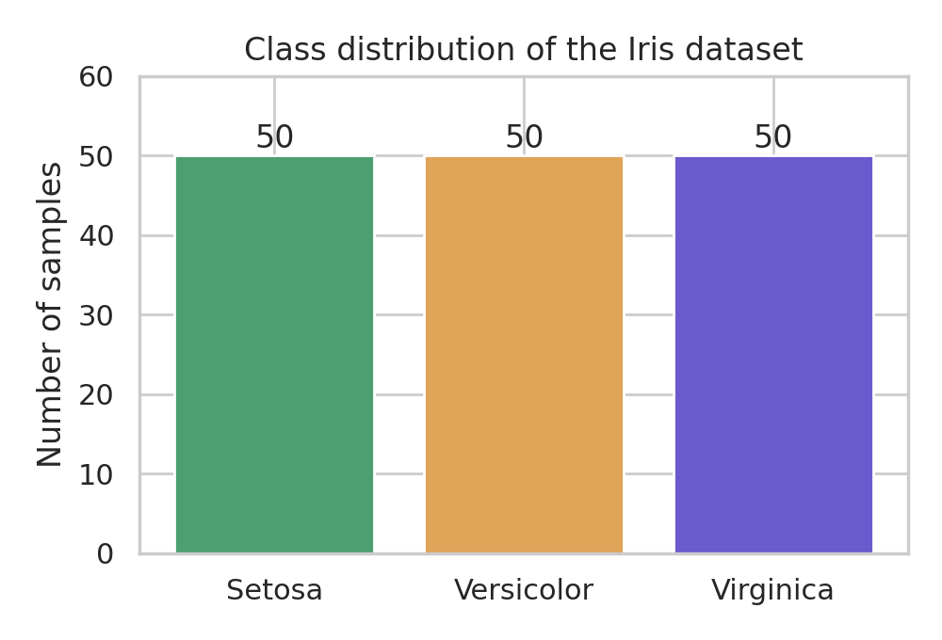
Figure 1: Class distribution of the Iris dataset.
Figure 1 shows that the three classes are perfectly balanced, with 50 samples each. A balanced data set means that accuracy is a fair performance measure and that no class dominates the training.
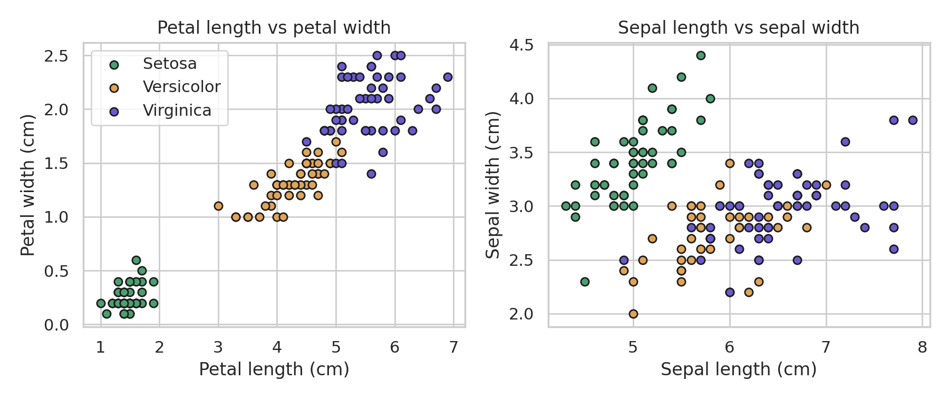
Figure 2: Scatter plots of petal length vs petal width (left) and sepal length vs sepal width (right).
Figure 2 shows that the petal measurements separate the three species very clearly: Setosa forms a distinct cluster far away from the other two classes, while Versicolor and Virginica lie close to each other with a small overlap. The sepal measurements show much more overlap between Versicolor and Virginica. This explains why a classifier is expected to identify Setosa easily, while confusion, if any, is most likely between Versicolor and Virginica.
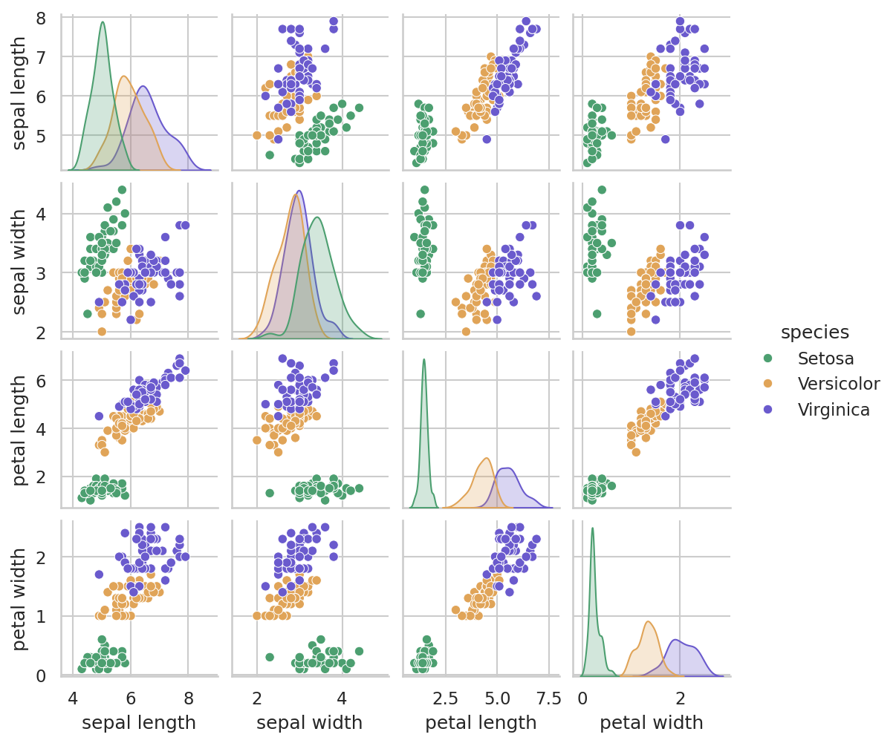
Figure 3: Pair plot of all four features, coloured by species.
The pair plot (Figure 3) shows every pair of features together with the distribution of each feature. Petal length and petal width show the strongest separation between classes.

CHAPTER 4 – NEURAL NETWORK ARCHITECTURE
A small fully connected (dense) network is used. The same architecture is used for every experiment in this project:
Table 4: Network architecture
Layer | Neurons | Activation | Parameters
Input layer | 4 (features) | – | 0
Hidden layer 1 | 16 | ReLU | 4 × 16 + 16 = 80
Hidden layer 2 | 8 | ReLU | 16 × 8 + 8 = 136
Output layer | 3 (classes) | Softmax | 8 × 3 + 3 = 27
Total |  |  | 243 trainable parameters

Why each layer is used:
- Input layer (4 nodes): one node for each of the four flower measurements.
- Hidden layer 1 (16 neurons, ReLU): the first hidden layer learns combinations of the input measurements. Sixteen neurons give the network enough flexibility for this simple problem.
- Hidden layer 2 (8 neurons, ReLU): the second hidden layer combines the first layer’s features into higher-level patterns. Using fewer neurons here gradually compresses the information towards the three classes.
- Output layer (3 neurons, Softmax): one neuron per class. Softmax converts the three raw scores into probabilities that sum to 1.
Why these activation functions: ReLU (Rectified Linear Unit), defined as f(z) = max(0, z), is simple, cheap to compute and widely used in hidden layers; it introduces the non-linearity that allows the network to learn more than straight-line relationships. Softmax, defined as p_{i} = exp(z_{i}) / Σ_{j} exp(z_{j}), turns the outputs into a probability distribution over the classes, which is what the cross-entropy loss expects. The layer sizes (16 and 8) are a simple, reasonable choice for this small problem; they were not tuned.

4.1 Model Parameters
Table 5: Summary of model settings
Item | Value
Number of layers | 4 (1 input, 2 hidden, 1 output); 3 layers with trainable weights
Number of neurons | 4 (input) + 16 + 8 + 3 = 31
Activation functions | ReLU (hidden layers), Softmax (output layer)
Output classes | 3 (Setosa, Versicolor, Virginica)
Weight initialisation | Glorot (Xavier) uniform for weights, zeros for biases (Keras defaults)
Loss function | Sparse categorical cross-entropy
Total trainable parameters | 243

4.2 Architecture Diagram
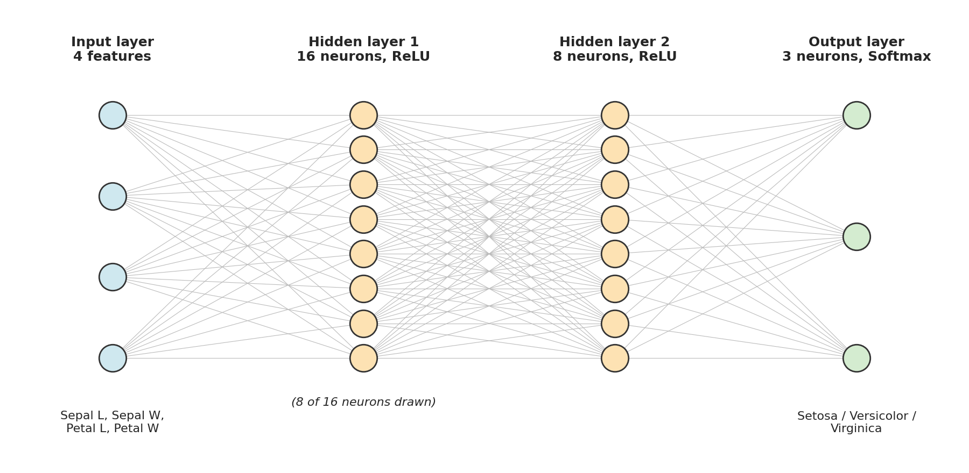
Figure 4: Architecture of the network: 4 Inputs → 16 Neurons → 8 Neurons → 3 Output Classes (only 8 of the 16 neurons of hidden layer 1 are drawn).
4 Inputs → 16 Neurons (ReLU) → 8 Neurons (ReLU) → 3 Output Classes (Softmax)

CHAPTER 5 – METHODOLOGY
The complete experimental workflow is as follows:
- Load the Iris dataset.
- Explore the dataset (shape, class counts, statistics, plots).
- Prepare the input features and labels.
- Split the dataset into training, validation and test sets.
- Scale the features with StandardScaler.
- Create the neural network (4 → 16 → 8 → 3).
- Compile the model with the SGD optimizer.
- Train the model.
- Record the training history (loss and accuracy for every epoch).
- Evaluate the model on the test set.
- Create an equivalent, fresh model for Adam.
- Train the model using Adam.
- Evaluate the Adam model on the same test set.
- Compare both optimizers.
- Visualise the training behaviour (loss and accuracy curves, confusion matrices).
- Analyse the results.
Fair-comparison rule. The same architecture, dataset split, preprocessing, number of epochs and batch size are used for both experiments, so that the optimizer is the main thing that differs. The same random seed is used, so both models start from identical initial weights and see the mini-batches in the same random order.
Table 6: Experimental settings
Setting | SGD experiment | Adam experiment
Architecture | 4 → 16 → 8 → 3 | 4 → 16 → 8 → 3
Initial weights | Same (seed 42) | Same (seed 42)
Train / validation / test samples | 96 / 24 / 30 | 96 / 24 / 30
Preprocessing | StandardScaler | StandardScaler
Loss function | Sparse categorical cross-entropy | Sparse categorical cross-entropy
Epochs | 100 | 100
Batch size | 16 (6 updates per epoch) | 16 (6 updates per epoch)
Optimizer | SGD, no momentum | Adam (β₁ = 0.9, β₂ = 0.999, ε = 10⁻⁷)
Learning rate | 0.01 (Keras default for SGD) | 0.001 (Keras default for Adam)

Learning rates. The learning rates are the default values used by Keras for each optimizer (0.01 for SGD and 0.001 for Adam). The comparison in Chapters 7–9 is therefore a comparison of the two optimizers with their usual default settings. Because the two learning rates are not equal, differences in the results are partly due to the optimizer and partly due to its learning rate; Chapter 10 examines the effect of the SGD learning rate separately.

CHAPTER 6 – PYTHON IMPLEMENTATION

6.1 Software Requirements
Table 7: Software and libraries
Software / Library | Purpose | Version used for the reported run
Python | Programming language | 3.12.3
Jupyter Notebook / Google Colab | Environment for running and documenting the code | Notebook file supplied (see Section 6.9)
NumPy | Numerical arrays and calculations | 2.4.4
Pandas | Tables (DataFrames) for data and results | 3.0.2
Matplotlib | Plotting graphs | 3.10.8
Seaborn (optional) | Pair plot of the dataset | 0.13.2
Scikit-learn | Iris dataset, data splitting, scaling, metrics | 1.8.0
TensorFlow / Keras | Building and training the neural network | Used by the supplied notebook (preinstalled in Google Colab)

All the code in this chapter can be pasted into consecutive cells of a Jupyter Notebook or Google Colab notebook and run from top to bottom. The same code is available in the supplied notebook file.

6.2 Import Libraries
import numpy as np
import pandas as pd
import matplotlib.pyplot as plt
import seaborn as sns # optional: used only for the pair plot
import tensorflow as tf
from tensorflow import keras
from tensorflow.keras import layers

from sklearn.datasets import load_iris
from sklearn.model_selection import train_test_split
from sklearn.preprocessing import StandardScaler
from sklearn.metrics import confusion_matrix, classification_report, ConfusionMatrixDisplay

SEED = 42 # random seed for reproducibility
EPOCHS = 100 # same number of epochs for every experiment
BATCH_SIZE = 16 # same batch size for every experiment
CLASS_NAMES = ["Setosa", "Versicolor", "Virginica"]

print("TensorFlow version:", tf.__version__)
Explanation. The first group of imports provides numerical, tabular and plotting tools. TensorFlow and Keras provide the neural-network layers, the optimizers and the training functions. The scikit-learn imports provide the dataset, the train-test split, the scaler and the evaluation metrics. The constants at the end fix the random seed, the number of epochs and the batch size, so that every experiment uses the same values.

6.3 Load Iris Dataset
iris = load_iris(as_frame=True) # Iris dataset bundled with scikit-learn
df = iris.frame.copy() # features + 'target' column in one DataFrame
df["species"] = df["target"].map(dict(enumerate(CLASS_NAMES)))

print("Shape of dataset:", df.shape)
print(df.head())
print()
print(df["species"].value_counts())
print()
print(df.describe().round(2))
Output:
Shape of dataset: (150, 6)
sepal length (cm) sepal width (cm) ... target species
0 5.1 3.5 ... 0 Setosa
1 4.9 3.0 ... 0 Setosa
2 4.7 3.2 ... 0 Setosa
3 4.6 3.1 ... 0 Setosa
4 5.0 3.6 ... 0 Setosa

[5 rows x 6 columns]

species
Setosa 50
Versicolor 50
Virginica 50
Name: count, dtype: int64

sepal length (cm) sepal width (cm) ... petal width (cm) target
count 150.00 150.00 ... 150.00 150.00
mean 5.84 3.06 ... 1.20 1.00
std 0.83 0.44 ... 0.76 0.82
min 4.30 2.00 ... 0.10 0.00
25% 5.10 2.80 ... 0.30 0.00
50% 5.80 3.00 ... 1.30 1.00
75% 6.40 3.30 ... 1.80 2.00
max 7.90 4.40 ... 2.50 2.00

[8 rows x 5 columns]
Explanation. load_iris(as_frame=True) returns the dataset as a Pandas DataFrame. A new column named species is added to make the output readable. The output confirms that the table has 150 rows (the columns shown are the four features, the numeric target and the species name) and that each class has 50 samples. Pandas shortens wide tables with “…” in the printout.
Code for the dataset visualisations (Section 3.5):
# (a) Class distribution
df["species"].value_counts().reindex(CLASS_NAMES).plot(kind="bar", color=["#4c9f70", "#e0a458", "#6a5acd"])
plt.title("Class distribution of the Iris dataset")
plt.ylabel("Number of samples")
plt.xticks(rotation=0)
plt.show()

# (b) Scatter plots of feature pairs
fig, axs = plt.subplots(1, 2, figsize=(10, 4))
for sp in CLASS_NAMES:
d = df[df["species"] == sp]
axs[0].scatter(d["petal length (cm)"], d["petal width (cm)"], label=sp)
axs[1].scatter(d["sepal length (cm)"], d["sepal width (cm)"], label=sp)
axs[0].set_xlabel("Petal length (cm)"); axs[0].set_ylabel("Petal width (cm)")
axs[1].set_xlabel("Sepal length (cm)"); axs[1].set_ylabel("Sepal width (cm)")
axs[0].legend()
plt.show()

# (c) Pair plot (optional)
sns.pairplot(df.drop(columns="target"), hue="species")
plt.show()

6.4 Data Preprocessing
# 1. Separate features (X) and labels (y)
X = iris.data.values.astype("float32") # shape (150, 4)
y = iris.target.values.astype("int64") # integer labels 0, 1, 2 (no one-hot encoding needed)

# 2. Hold out 20 % of the data as the TEST set
X_trainval, X_test, y_trainval, y_test = train_test_split(
X, y, test_size=0.2, random_state=SEED, stratify=y)

# 3. Split the remaining data into TRAINING (80 %) and VALIDATION (20 %) sets
X_train, X_val, y_train, y_val = train_test_split(
X_trainval, y_trainval, test_size=0.2, random_state=SEED, stratify=y_trainval)

# 4. Standardise the features (fit ONLY on the training data)
scaler = StandardScaler().fit(X_train)
X_train = scaler.transform(X_train)
X_val = scaler.transform(X_val)
X_test = scaler.transform(X_test)

print("Training samples :", X_train.shape[0])
print("Validation samples:", X_val.shape[0])
print("Test samples :", X_test.shape[0])
Output:
Training samples : 96
Validation samples: 24
Test samples : 30
Explanation.
- X holds the four features and y holds the integer class labels, so no label encoding is needed.
- The first train_test_split keeps 20 % of the data (30 samples) as the final test set. The second split divides the remaining 120 samples into 96 training and 24 validation samples. stratify keeps equal class proportions and random_state = SEED makes the split identical every time.
- StandardScaler is fitted on the training data only (fit) and then applied to all three subsets (transform). This avoids data leakage from the validation and test sets.

6.5 Build Neural Network
def build_model(seed=SEED):
"""Create a fresh 4-16-8-3 network. Re-seeding gives identical initial weights."""
tf.keras.utils.set_random_seed(seed)
model = keras.Sequential([
keras.Input(shape=(4,)),
layers.Dense(16, activation="relu", name="hidden_1"),
layers.Dense(8, activation="relu", name="hidden_2"),
layers.Dense(3, activation="softmax", name="output"),
])
return model

build_model().summary()
Explanation. The function build_model() creates a new network each time it is called. keras.Input(shape=(4,)) declares four input features. The two Dense layers with ReLU activation are the hidden layers (16 and 8 neurons), and the final Dense layer with 3 neurons and Softmax activation gives the class probabilities. Calling tf.keras.utils.set_random_seed(seed) at the start of the function means every new model starts with identical initial weights; this is what makes the SGD and Adam experiments start from the same point. The model has 80 + 136 + 27 = 243 trainable parameters, as shown in Table 4 and in the output of model.summary().

6.6 Train Using SGD
model_sgd = build_model()

model_sgd.compile(
optimizer=keras.optimizers.SGD(learning_rate=0.01), # SGD (Keras default learning rate)
loss="sparse_categorical_crossentropy",
metrics=["accuracy"],
)

history_sgd = model_sgd.fit(
X_train, y_train,
validation_data=(X_val, y_val),
epochs=EPOCHS,
batch_size=BATCH_SIZE,
verbose=0,
)
print("SGD training finished.")
Explanation. compile() chooses the optimizer, the loss function and the metric to be recorded. Here the optimizer is keras.optimizers.SGD with a learning rate of 0.01. fit() trains the model for 100 epochs with mini-batches of 16 samples. validation_data supplies the validation set, which is only evaluated after each epoch and is not used to change the weights. fit() returns a History object whose history dictionary stores loss, accuracy, val_loss and val_accuracy for every epoch; this is stored in history_sgd.

6.7 Train Using Adam
model_adam = build_model() # fresh model: same architecture, same initial weights

model_adam.compile(
optimizer=keras.optimizers.Adam(learning_rate=0.001), # Adam (Keras default learning rate)
loss="sparse_categorical_crossentropy",
metrics=["accuracy"],
)

history_adam = model_adam.fit(
X_train, y_train,
validation_data=(X_val, y_val),
epochs=EPOCHS, # same as SGD
batch_size=BATCH_SIZE, # same as SGD
verbose=0,
)
print("Adam training finished.")
Explanation. A fresh model is created with build_model(), so it has the same architecture and the same initial weights as the SGD model but none of its trained weights. The only change in the compile step is the optimizer, keras.optimizers.Adam with the default learning rate 0.001. The data, epochs and batch size are exactly the same as in the SGD experiment.

6.8 Model Evaluation
results = {}
for name, model, hist in [("SGD", model_sgd, history_sgd), ("Adam", model_adam, history_adam)]:
test_loss, test_acc = model.evaluate(X_test, y_test, verbose=0)
h = hist.history
results[name] = {
"Final Training Loss": h["loss"][-1],
"Final Validation Loss": h["val_loss"][-1],
"Final Training Accuracy": h["accuracy"][-1],
"Final Validation Accuracy": h["val_accuracy"][-1],
"Test Loss": test_loss,
"Test Accuracy": test_acc,
}
print(f"{name:5s} -> Test loss: {test_loss:.4f} | Test accuracy: {test_acc:.4f}")

print()
print(pd.DataFrame(results).round(4))
Output:
SGD -> Test loss: 0.2965 | Test accuracy: 0.8333
Adam -> Test loss: 0.1716 | Test accuracy: 0.9000

SGD Adam
Final Training Loss 0.2401 0.1012
Final Validation Loss 0.2632 0.1919
Final Training Accuracy 0.9167 0.9583
Final Validation Accuracy 0.8750 0.9167
Test Loss 0.2965 0.1716
Test Accuracy 0.8333 0.9000
Explanation. model.evaluate() calculates the loss and accuracy on the test set, which the models never used during training. The final training and validation values are taken from the last epoch of the stored history. The program output above gives the actual values obtained in this project.
Printing the training history at selected epochs:
def history_table(h, epochs=(1, 10, 25, 50, 75, 100)):
t = pd.DataFrame({
"Epoch": epochs,
"Train Loss": [h["loss"][e - 1] for e in epochs],
"Train Acc": [h["accuracy"][e - 1] for e in epochs],
"Val Loss": [h["val_loss"][e - 1] for e in epochs],
"Val Acc": [h["val_accuracy"][e - 1] for e in epochs],
})
return t.round(4).to_string(index=False)

print("SGD (learning rate = 0.01)"); print(history_table(history_sgd.history)); print()
print("Adam (learning rate = 0.001)"); print(history_table(history_adam.history))

6.9 Note on How the Reported Results Were Generated
Please read. The Keras code in Sections 6.2–6.8 is the intended implementation and is supplied as a Jupyter notebook (Optimizer_Comparison_Iris.ipynb). The numerical results, tables, graphs, confusion matrices and classification reports in Chapters 7–13 were produced by running an equivalent from-scratch NumPy implementation of the same experiment (supplied as run_experiment_numpy.py). It uses the same 4–16–8–3 architecture, Glorot-uniform weight initialisation, zero biases, sparse categorical cross-entropy, the same SGD and Adam update rules as Keras (including Adam’s default β₁ = 0.9, β₂ = 0.999, ε = 10⁻⁷), the same data split and scaling, the same batch size of 16 and the same 100 epochs. As in Keras, the reported training loss and accuracy of each epoch are averages taken over the mini-batches during that epoch.
Random-number generators differ between libraries, so a run of the Keras notebook will start from different (but similarly distributed) initial weights and will not reproduce every digit shown here. The qualitative behaviour is expected to be similar, but exact values and some statements in the analysis (for example, which epoch first crosses a given loss level) may differ slightly. Running the notebook and comparing its output with this report is therefore recommended; the values in this report are the actual outputs of the program that was executed.

CHAPTER 7 – RESULTS AND VISUALIZATION

7.1 SGD Training Results
The SGD model (learning rate 0.01) was trained for 100 epochs. The program output below shows its history at selected epochs.
Output:
SGD (learning rate = 0.01)
Epoch Train Loss Train Acc Val Loss Val Acc
1 0.8711 0.6979 0.8325 0.6667
10 0.6890 0.8333 0.6471 0.7500
25 0.4995 0.8542 0.4760 0.7917
50 0.3591 0.8854 0.3591 0.7917
75 0.2886 0.8958 0.3020 0.8750
100 0.2401 0.9167 0.2632 0.8750
Table 8: Final results of the SGD experiment (training loss, accuracy and validation values are from epoch 100)
Metric | Value
Training loss | 0.2401
Validation loss | 0.2632
Training accuracy | 0.9167 (91.67%)
Validation accuracy | 0.8750 (87.50%)
Test loss | 0.2965
Test accuracy | 0.8333 (83.33%)

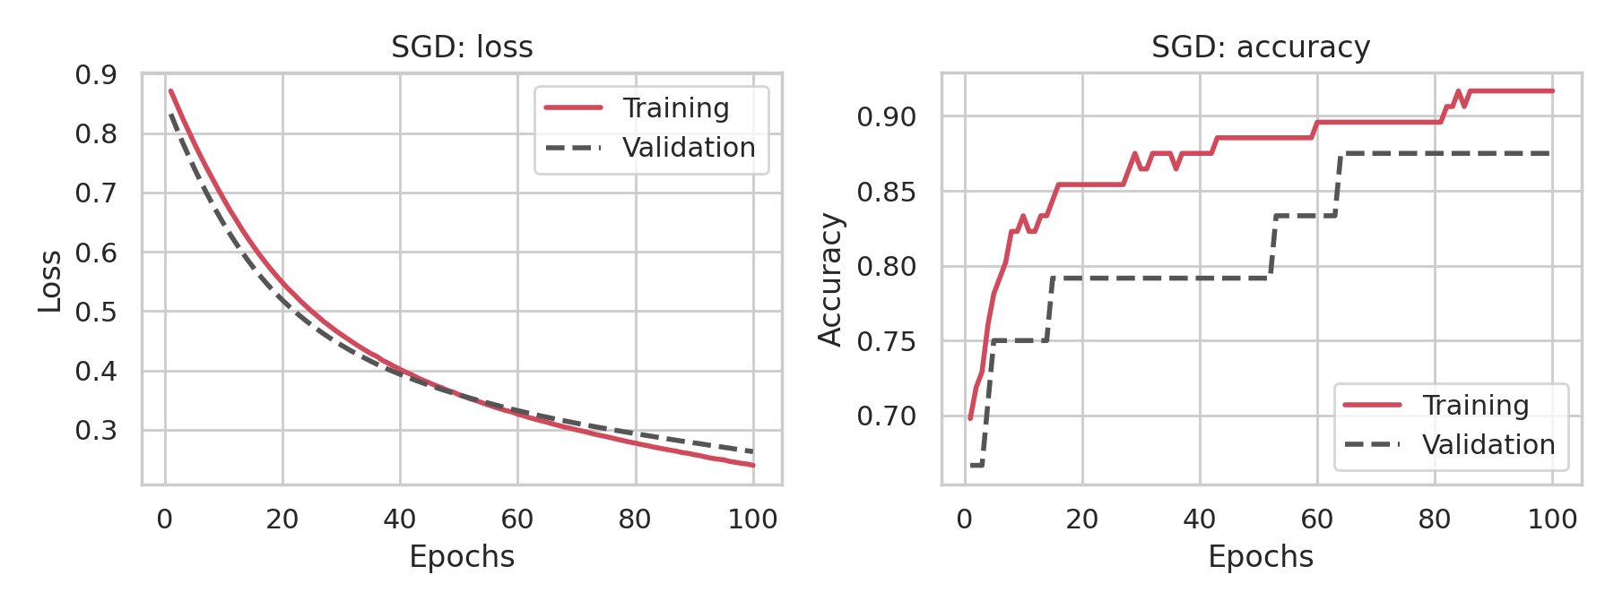
Figure 5: SGD (lr = 0.01): training and validation loss (left) and accuracy (right).
The SGD training loss fell steadily from 0.8711 in the first epoch to 0.2401 in the last epoch, and the validation loss followed a very similar path (final value 0.2632). The curves were still sloping downwards at epoch 100.

7.2 Adam Training Results
The Adam model (learning rate 0.001) was trained under the same conditions.
Output:
Adam (learning rate = 0.001)
Epoch Train Loss Train Acc Val Loss Val Acc
1 0.8654 0.7083 0.8190 0.6667
10 0.6115 0.8333 0.5808 0.7917
25 0.3920 0.8750 0.4064 0.7917
50 0.2509 0.9167 0.3085 0.8333
75 0.1488 0.9583 0.2282 0.9167
100 0.1012 0.9583 0.1919 0.9167
Table 9: Final results of the Adam experiment (training loss, accuracy and validation values are from epoch 100)
Metric | Value
Training loss | 0.1012
Validation loss | 0.1919
Training accuracy | 0.9583 (95.83%)
Validation accuracy | 0.9167 (91.67%)
Test loss | 0.1716
Test accuracy | 0.9000 (90.00%)

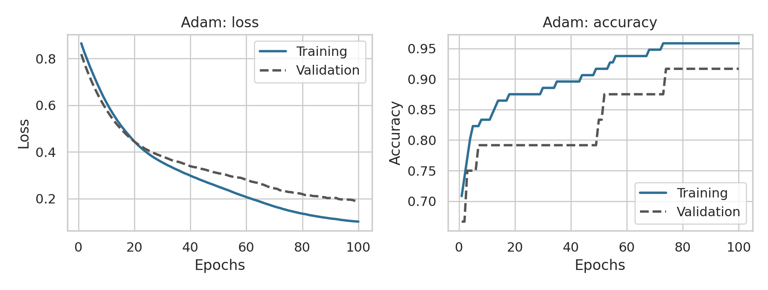
Figure 6: Adam (lr = 0.001): training and validation loss (left) and accuracy (right).
The Adam training loss fell from 0.8654 to 0.1012, and the validation loss from 0.8190 to 0.1919. Compared with SGD, the gap between the validation loss and the training loss at the end is larger (0.0906 for Adam against 0.0230 for SGD).

7.3 Accuracy Comparison
Table 10: Comparison of final accuracy and test loss
Metric | SGD | Adam
Final Training Accuracy | 0.9167 | 0.9583
Final Validation Accuracy | 0.8750 | 0.9167
Test Accuracy | 0.8333 | 0.9000
Test Loss | 0.2965 | 0.1716

Validation accuracy is measured on 24 samples, so it can only change in steps of 1/24 (about 4.2 percentage points). Test accuracy is measured on 30 samples, so one test sample corresponds to about 3.3 percentage points. These small sample sizes should be kept in mind when interpreting the differences.

7.4 Loss Comparison Graph
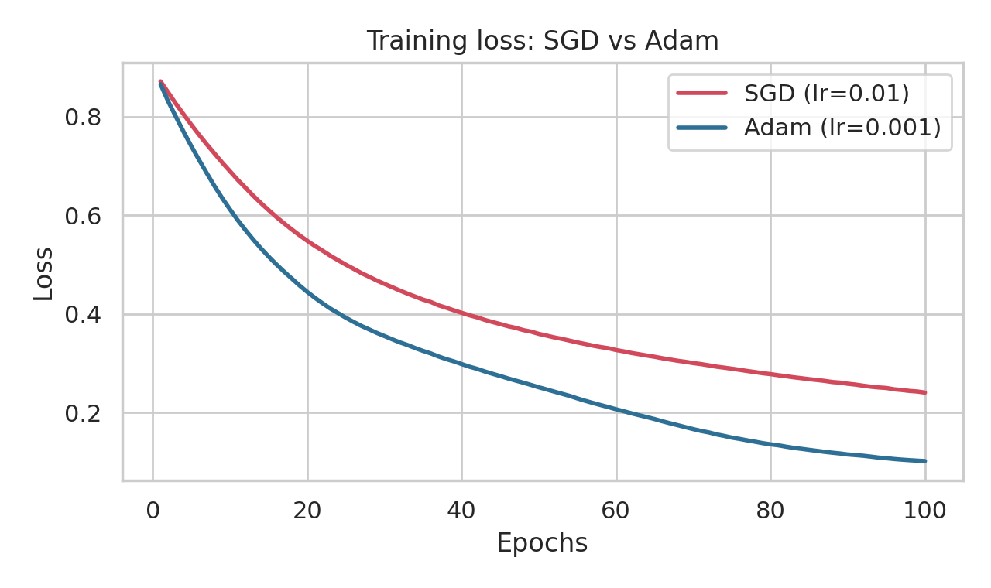
Figure 7: Training loss of SGD and Adam against epochs.
Both curves start at almost the same loss (0.8711 for SGD and 0.8654 for Adam), but the Adam curve is below the SGD curve at every later epoch, and the distance between the two grows during training.

7.5 Validation Loss Comparison
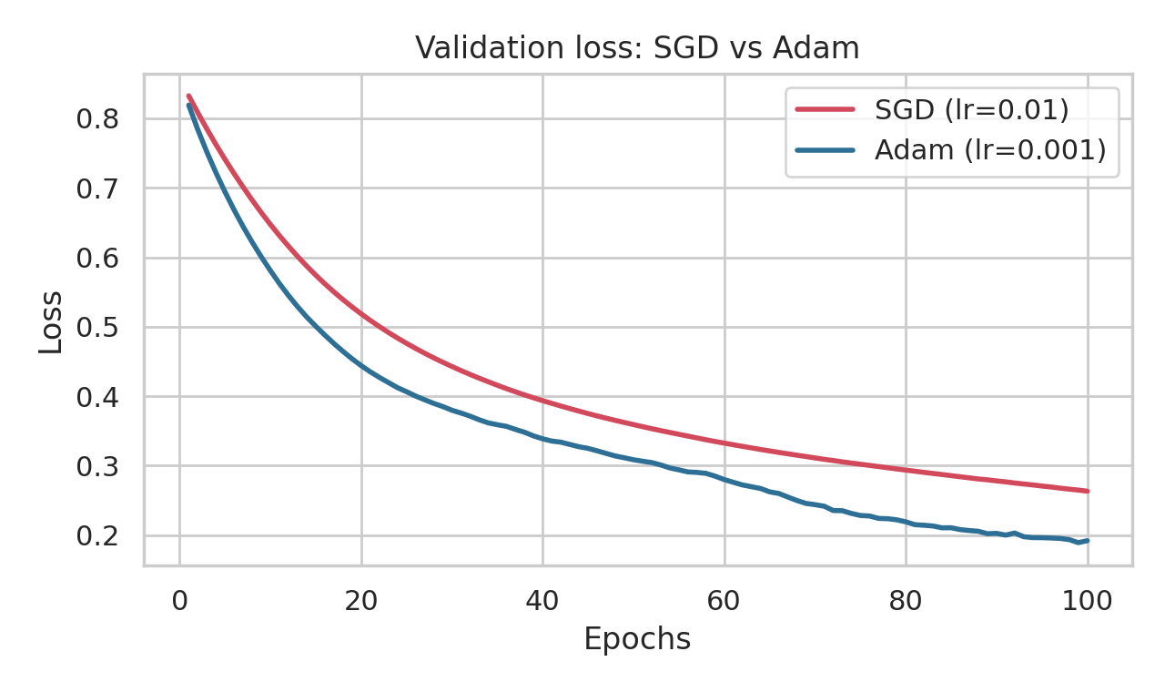
Figure 8: Validation loss of SGD and Adam against epochs.
The validation loss of Adam is lower than that of SGD at every epoch. Both curves decrease smoothly and neither shows a clear upward trend within the 100 epochs.

7.6 Accuracy Comparison Graph
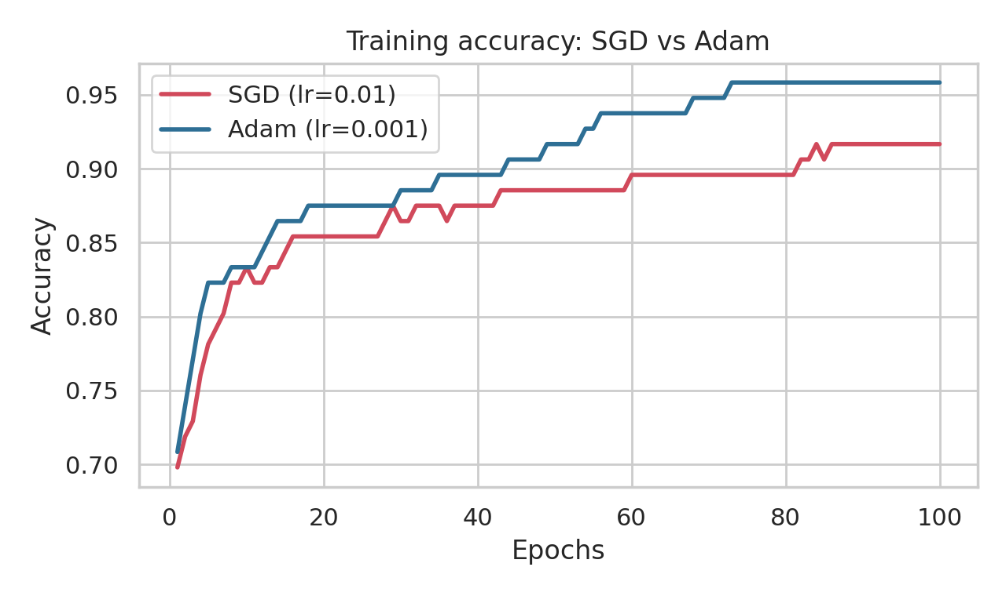
Figure 9: Training accuracy of SGD and Adam against epochs.
The training accuracy of both optimizers rises quickly in the first few epochs and then increases slowly. Adam’s training accuracy was higher than or equal to SGD’s at every one of the 100 epochs (strictly higher in 98 of them).

7.7 Validation Accuracy Comparison
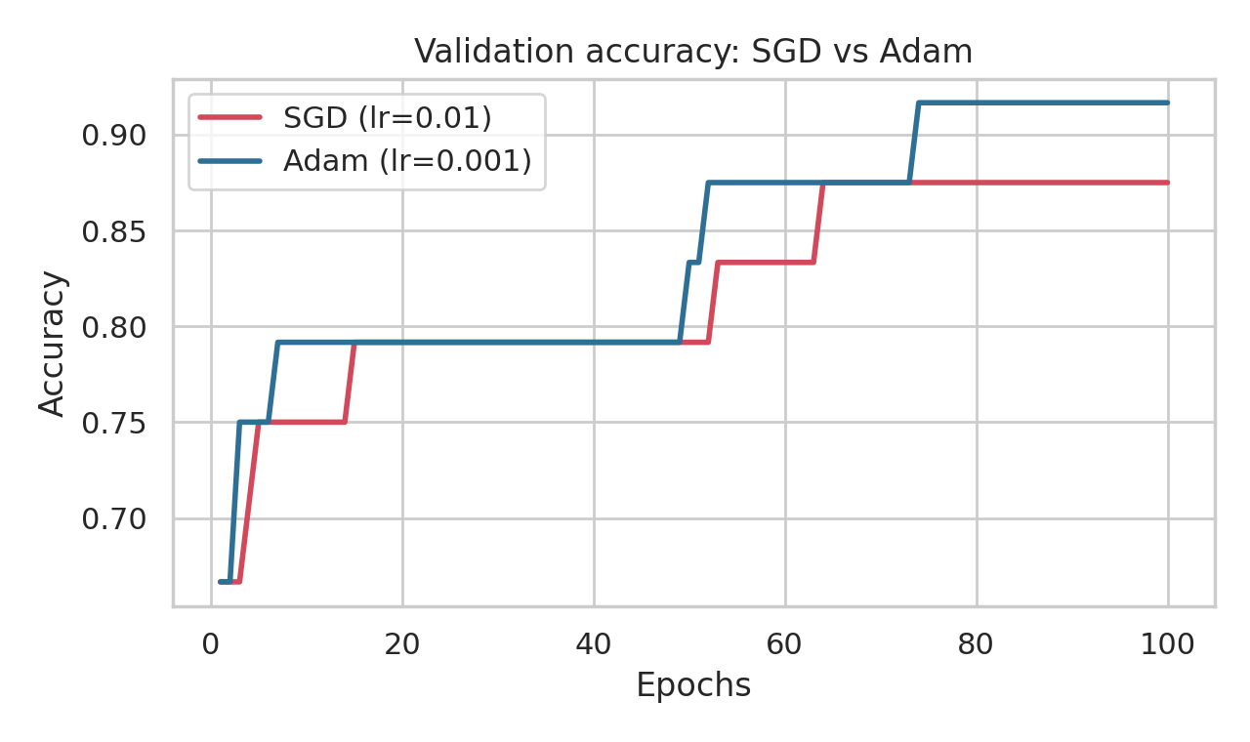
Figure 10: Validation accuracy of SGD and Adam against epochs.
The validation accuracy curves are step-shaped because the validation set contains only 24 samples. Adam’s validation accuracy was never lower than SGD’s at any epoch (it was strictly higher in about half of the epochs) and it finished higher.

CHAPTER 8 – CLASSIFICATION PERFORMANCE
Both trained models were evaluated on the same 30 test samples that were not used for training or validation.

8.1 Predictions
pred_sgd = np.argmax(model_sgd.predict(X_test, verbose=0), axis=1)
pred_adam = np.argmax(model_adam.predict(X_test, verbose=0), axis=1)

comparison = pd.DataFrame({
"True": [CLASS_NAMES[i] for i in y_test],
"SGD": [CLASS_NAMES[i] for i in pred_sgd],
"Adam": [CLASS_NAMES[i] for i in pred_adam],
})
print(comparison)
Table 11: Predictions on the 30 test samples (shaded cells are misclassifications)
Test sample | True class | SGD prediction | Adam prediction
0 | Setosa | Setosa | Setosa
1 | Virginica | Virginica | Virginica
2 | Versicolor | Versicolor | Versicolor
3 | Versicolor | Versicolor | Versicolor
4 | Setosa | Setosa | Setosa
5 | Versicolor | Virginica | Virginica
6 | Setosa | Setosa | Setosa
7 | Setosa | Setosa | Setosa
8 | Virginica | Virginica | Virginica
9 | Versicolor | Versicolor | Versicolor
10 | Virginica | Virginica | Virginica
11 | Virginica | Virginica | Virginica
12 | Virginica | Virginica | Virginica
13 | Versicolor | Virginica | Versicolor
14 | Setosa | Setosa | Setosa
15 | Setosa | Setosa | Setosa
16 | Setosa | Setosa | Setosa
17 | Versicolor | Versicolor | Versicolor
18 | Versicolor | Versicolor | Versicolor
19 | Virginica | Virginica | Virginica
20 | Setosa | Setosa | Setosa
21 | Virginica | Virginica | Virginica
22 | Versicolor | Versicolor | Versicolor
23 | Virginica | Versicolor | Versicolor
24 | Virginica | Virginica | Virginica
25 | Versicolor | Virginica | Virginica
26 | Versicolor | Virginica | Versicolor
27 | Setosa | Setosa | Setosa
28 | Virginica | Virginica | Virginica
29 | Setosa | Setosa | Setosa

SGD misclassified 5 of 30 test samples (sample numbers 5, 13, 23, 25, 26) and Adam misclassified 3 (sample numbers 5, 23, 25). Samples 5, 23, 25 were misclassified by both models; samples 13 and 26 were misclassified only by SGD, and no sample was misclassified only by Adam. All errors are between Versicolor and Virginica; every Setosa flower was classified correctly by both models.

8.2 Confusion Matrix
A confusion matrix is a table that shows, for each true class (rows), how many samples were predicted as each class (columns). Correct predictions lie on the diagonal.
fig, axs = plt.subplots(1, 2, figsize=(10, 4))
for ax, name, pred in zip(axs, ["SGD", "Adam"], [pred_sgd, pred_adam]):
cm = confusion_matrix(y_test, pred)
ConfusionMatrixDisplay(cm, display_labels=CLASS_NAMES).plot(ax=ax, cmap="Blues", colorbar=False)
ax.set_title(f"Confusion matrix: {name}")
plt.tight_layout(); plt.show()
Output:
Confusion matrix (SGD):
[[10 0 0]
[ 0 6 4]
[ 0 1 9]]

Confusion matrix (Adam):
[[10 0 0]
[ 0 8 2]
[ 0 1 9]]
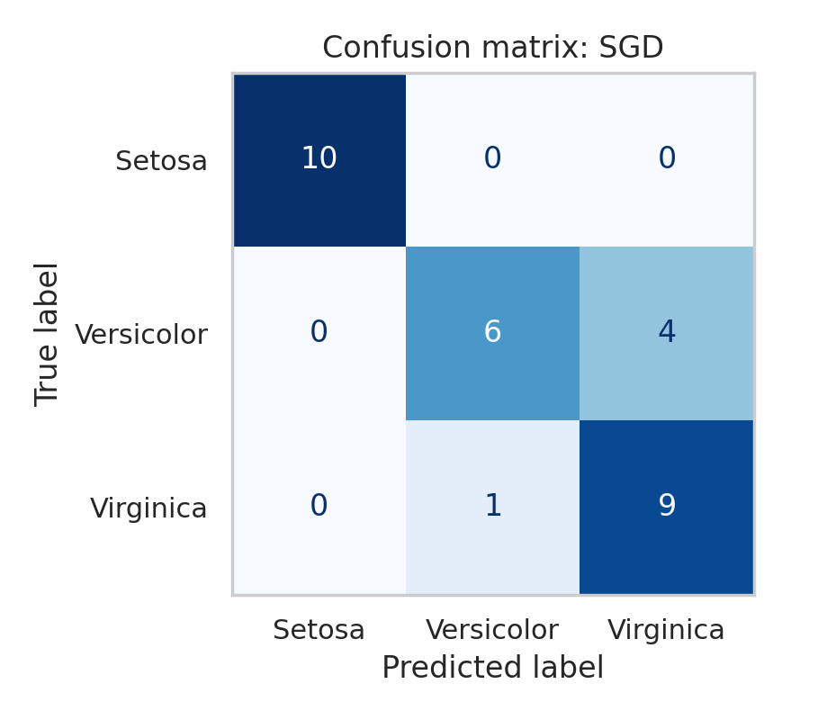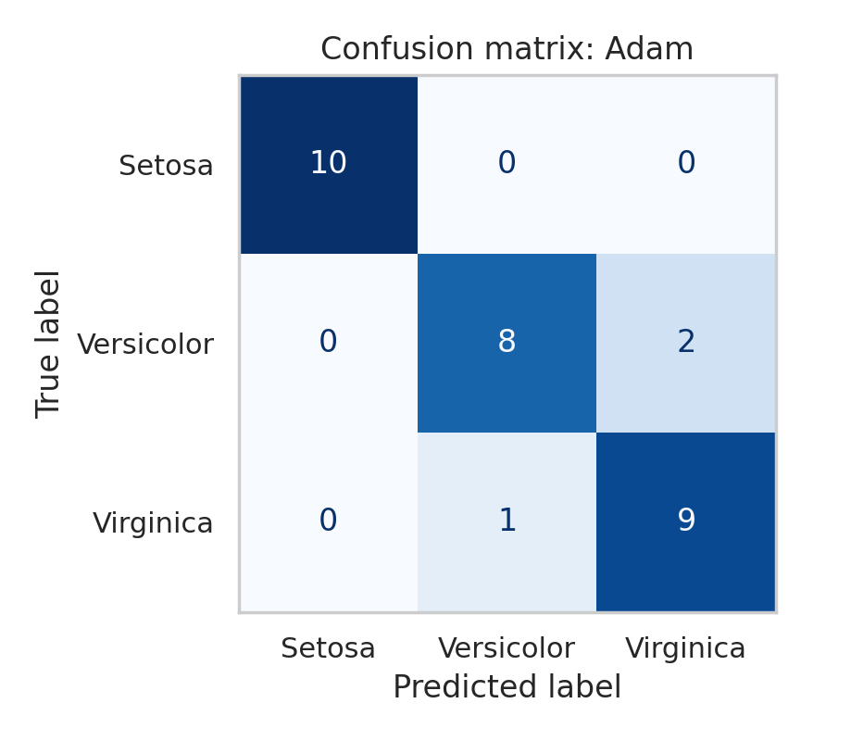
Figure 11: Confusion matrices on the test set for SGD (left) and Adam (right).
For SGD, all 10 Setosa flowers were correct, 6 of 10 Versicolor flowers were correct (4 were predicted as Virginica) and 9 of 10 Virginica flowers were correct (1 was predicted as Versicolor). For Adam, all 10 Setosa flowers were correct, 8 of 10 Versicolor flowers were correct (2 were predicted as Virginica) and 9 of 10 Virginica flowers were correct (1 was predicted as Versicolor).

8.3 Classification Report
print("===== SGD =====")
print(classification_report(y_test, pred_sgd, target_names=CLASS_NAMES, digits=4))
print("===== Adam =====")
print(classification_report(y_test, pred_adam, target_names=CLASS_NAMES, digits=4))
Output:
===== SGD =====
precision recall f1-score support

Setosa 1.0000 1.0000 1.0000 10
Versicolor 0.8571 0.6000 0.7059 10
Virginica 0.6923 0.9000 0.7826 10

accuracy 0.8333 30
macro avg 0.8498 0.8333 0.8295 30
weighted avg 0.8498 0.8333 0.8295 30

===== Adam =====
precision recall f1-score support

Setosa 1.0000 1.0000 1.0000 10
Versicolor 0.8889 0.8000 0.8421 10
Virginica 0.8182 0.9000 0.8571 10

accuracy 0.9000 30
macro avg 0.9024 0.9000 0.8997 30
weighted avg 0.9024 0.9000 0.8997 30
Meaning of the columns:
- Precision: of all samples predicted as a class, the fraction that really belong to that class (TP / (TP + FP)).
- Recall: of all samples that really belong to a class, the fraction that was found (TP / (TP + FN)).
- F1-score: the harmonic mean of precision and recall, 2 × (precision × recall) / (precision + recall).
- Support: the number of true test samples of the class (10 for each class).
- Macro average: the simple average over the three classes. Weighted average: the average weighted by the support of each class (identical here because the classes have equal support).

8.4 Performance Comparison
Table 12: Per-class and average test metrics (support = 10 per class)
Class | Precision SGD | Precision Adam | Recall SGD | Recall Adam | F1 SGD | F1 Adam
Setosa | 1.0000 | 1.0000 | 1.0000 | 1.0000 | 1.0000 | 1.0000
Versicolor | 0.8571 | 0.8889 | 0.6000 | 0.8000 | 0.7059 | 0.8421
Virginica | 0.6923 | 0.8182 | 0.9000 | 0.9000 | 0.7826 | 0.8571
Macro average | 0.8498 | 0.9024 | 0.8333 | 0.9000 | 0.8295 | 0.8997

Table 13: Overall test performance
Metric | SGD | Adam
Test accuracy | 0.8333 | 0.9000
Correctly classified samples | 25 of 30 | 27 of 30
Test loss | 0.2965 | 0.1716
Macro F1-score | 0.8295 | 0.8997

Both models classify Setosa perfectly. The difference between the models comes from Versicolor and Virginica: Adam found 8 of the 10 Versicolor flowers while SGD found 6, which raises Adam’s recall for Versicolor and its precision for Virginica.

CHAPTER 9 – OPTIMIZER COMPARISON AND ANALYSIS
Reading guide. Statements in this chapter that begin with “In this experiment” describe what was observed for this dataset, architecture and set of hyperparameters (SGD with learning rate 0.01, Adam with learning rate 0.001, 100 epochs, batch size 16). They are not general claims about the two optimizers.

9.1 Training Speed
Table 14: Training loss at selected epochs
Epoch | 1 | 10 | 20 | 40 | 60 | 80 | 100
SGD | 0.8711 | 0.6890 | 0.5480 | 0.4018 | 0.3264 | 0.2776 | 0.2401
Adam | 0.8654 | 0.6115 | 0.4443 | 0.2980 | 0.2063 | 0.1352 | 0.1012

In the first epoch the two optimizers were almost identical (0.8711 and 0.8654). Afterwards Adam’s loss decreased faster. Over the first 10 epochs the training loss decreased by about 0.020 per epoch for SGD and 0.028 per epoch for Adam. Adam’s training loss first fell to 0.5 or below at epoch 17, whereas SGD needed 25 epochs. Adam reached a training loss of 0.2 or below at epoch 62; SGD had not reached this level at epoch 100 (its final loss was 0.2401).
The speed of improvement also decreased for both optimizers as training progressed: in the last 10 epochs the average decrease per epoch was only about 0.0018 for SGD and 0.0013 for Adam. In this experiment, Adam with learning rate 0.001 was therefore faster than SGD with learning rate 0.01 in reducing the training loss.

9.2 Loss Behavior
Both training-loss curves are smooth and decrease at every epoch; they show no spikes or oscillations. This smoothness is partly because the plotted training loss is an average over the mini-batches of each epoch, which hides the noise of individual SGD updates. The SGD validation loss never increased from one epoch to the next (0 increases in 99 steps). The Adam validation loss increased in 4 of 99 steps, each time by less than 0.003, and was otherwise decreasing. At epoch 100 the validation loss of SGD was 0.2632 and that of Adam was 0.1919.
Adam’s validation loss (0.1919) was 0.0906 higher than its training loss (0.1012), a larger gap than for SGD (0.0230). A small gap is normal because the training loss is computed on data the model learns from. Since the validation loss was still falling (its lowest value was at epoch 99 for Adam and epoch 100 for SGD), there is no clear sign of overfitting within 100 epochs. Because the validation set has only 24 samples, this conclusion is tentative.

9.3 Accuracy Behavior
Table 15: Training and validation accuracy at selected epochs
Metric | Epoch 20 | Epoch 40 | Epoch 60 | Epoch 80 | Epoch 100
SGD training | 0.8542 | 0.8750 | 0.8958 | 0.8958 | 0.9167
Adam training | 0.8750 | 0.8958 | 0.9375 | 0.9583 | 0.9583
SGD validation | 0.7917 | 0.7917 | 0.8333 | 0.8750 | 0.8750
Adam validation | 0.7917 | 0.7917 | 0.8750 | 0.9167 | 0.9167

Training accuracy increased gradually for both optimizers and was higher for Adam at each of these epochs. Validation accuracy increased in steps: SGD first reached a validation accuracy of about 87.5 % at epoch 64 and stayed there, whereas Adam first reached it at epoch 52 and reached 91.7 % at epoch 74. SGD did not reach 90 % validation accuracy within 100 epochs. The final training accuracy was higher than the final validation accuracy for both optimizers by the same margin (4.17%), which corresponds to one sample out of 24 validation samples.

9.4 Test Performance
On the test set, Adam obtained a test loss of 0.1716 and a test accuracy of 90.00% (27 of 30 samples correct), while SGD obtained a test loss of 0.2965 and a test accuracy of 83.33% (25 of 30). The macro F1-scores were 0.8997 (Adam) and 0.8295 (SGD). The difference of two test samples is meaningful as an observation for this run, but with only 30 test samples it is not strong statistical evidence, which is why repeated runs are examined in Section 9.8.

9.5 Convergence Behavior
Neither optimizer had fully converged after 100 epochs: in both cases the training and validation losses were still decreasing at the end of training. In this experiment, Adam moved into a lower-loss region sooner. Its training loss passed the level 0.5 at epoch 17 (SGD: epoch 25) and the level 0.2 at epoch 62 (SGD: not reached). Its validation accuracy settled at 87.5 % from epoch 52 and at 91.7 % from epoch 74, while SGD’s validation accuracy settled at 87.5 % from epoch 64.
This statement is based on the plotted curves of this single experiment. The results do not show that Adam converges sooner than SGD in general. An SGD run with a larger learning rate behaves differently, as Chapter 10 shows.

9.6 Learning Rate
The learning rate η controls how far the parameters move in each update. In SGD the update is η times the gradient, so the actual step size depends directly on both η and the size of the gradient. If η is too small, the loss decreases very slowly; if η is too large, the updates can overshoot, the loss can oscillate and training may become unstable. The best value depends on the problem, and it often has to be found by experiment.
Adam also has a learning rate, but its update divides the smoothed gradient by the square root of the running average of squared gradients. As a result, the size of the step for each parameter is of the order of the learning rate, largely independent of how large the raw gradient is, and parameters with consistently small gradients still receive useful steps. This is what is meant by Adam using adaptive, parameter-specific step sizes. It is one reason why a small value such as 0.001 often works acceptably without much tuning, but a learning rate that suits one problem may still be poor for another.
In this project the two default learning rates were used (0.01 for SGD, 0.001 for Adam). Because they are not equal, the comparison in Sections 9.1–9.5 mixes the effect of the optimizer with the effect of its learning rate. The experiment in Chapter 10 shows that the SGD learning rate has a very large effect on the result.

9.7 Overall Experimental Observations
- Both optimizers learned the task: both trained models classified all Setosa flowers correctly and made errors only between Versicolor and Virginica.
- With the default learning rates and 100 epochs, Adam reduced the training loss faster and reached a lower final training loss (0.1012 vs 0.2401) and validation loss (0.1919 vs 0.2632).
- Adam obtained a higher test accuracy (90.00% vs 83.33%) and a lower test loss (0.1716 vs 0.2965) in this run, a difference of two test samples.
- The loss curves of both optimizers were smooth; neither showed instability at the chosen learning rates.
- Neither optimizer had completely converged at 100 epochs.
- SGD’s performance depends strongly on its learning rate (Chapter 10), so the ranking observed here applies to the specific settings used and should not be generalised.

9.8 Supplementary Check: Repeated Runs
A single run can be affected by the particular random initial weights and the random order of the mini-batches, and the test set is small. To see how much the results vary, each optimizer (same settings as before) was trained 10 times with different random seeds for the initial weights and the mini-batch shuffling. The data split and test set were kept the same. The code is given below, and the results are summarised in the table that follows the output.
def run_once(opt_name, seed):
m = build_model(seed) # different initial weights and shuffling for each seed
opt = (keras.optimizers.SGD(learning_rate=0.01) if opt_name == "SGD"
else keras.optimizers.Adam(learning_rate=0.001))
m.compile(optimizer=opt, loss="sparse_categorical_crossentropy", metrics=["accuracy"])
m.fit(X_train, y_train, validation_data=(X_val, y_val),
epochs=EPOCHS, batch_size=BATCH_SIZE, verbose=0)
return m.evaluate(X_test, y_test, verbose=0) # (test_loss, test_accuracy)

for opt_name in ["SGD", "Adam"]:
outs = np.array([run_once(opt_name, s) for s in range(10)])
print(f"{opt_name:5s} test accuracy: mean = {outs[:,1].mean():.4f}, std = {outs[:,1].std():.4f}, "
f"min = {outs[:,1].min():.4f}, max = {outs[:,1].max():.4f}")
Output:
SGD test accuracy: mean = 0.8167, std = 0.0619, min = 0.7000, max = 0.9000
Adam test accuracy: mean = 0.9100, std = 0.0335, min = 0.8333, max = 0.9333
Table 16: Test results over 10 repeated runs (different initial weights and shuffling; standard deviation is the population standard deviation)
Optimizer | Mean test accuracy | Std. dev. | Min | Max | Mean test loss | Runs with train loss ≤ 0.2 within 100 epochs
SGD (lr 0.01) | 0.8167 | 0.0619 | 0.7000 | 0.9000 | 0.3664 | 2 of 10 (epochs 90–94)
Adam (lr 0.001) | 0.9100 | 0.0335 | 0.8333 | 0.9333 | 0.2094 | 9 of 10 (epochs 51–81)

Over the 10 runs, Adam’s mean test accuracy (91.00%) was higher than SGD’s (81.67%) and its range was narrower, and Adam reached a training loss of 0.2 or below in 9 of 10 runs against 2 of 10 for SGD. The runs differ noticeably from each other (SGD test accuracy ranged from 70.00% to 90.00%), which confirms that single-run differences of a few percentage points on a 30-sample test set must be interpreted carefully. This pattern holds for these default learning rates and this setup; it is not a statement about all learning rates or all datasets.

CHAPTER 10 – HYPERPARAMETER EXPERIMENT
The learning rate is one of the most important hyperparameters of SGD. In this additional experiment, the same network was trained with SGD using three learning rates (0.001, 0.01 and 0.1). Everything else (initial weights, data split, batch size, 100 epochs) was kept the same as in the main experiment.
lr_rows = []
plt.figure(figsize=(7, 4))
for lr in [0.001, 0.01, 0.1]:
m = build_model() # same initial weights every time
m.compile(optimizer=keras.optimizers.SGD(learning_rate=lr),
loss="sparse_categorical_crossentropy", metrics=["accuracy"])
h = m.fit(X_train, y_train, validation_data=(X_val, y_val),
epochs=EPOCHS, batch_size=BATCH_SIZE, verbose=0)
t_loss, t_acc = m.evaluate(X_test, y_test, verbose=0)
lr_rows.append({"SGD Learning Rate": lr,
"Final Train Loss": h.history["loss"][-1],
"Final Val Loss": h.history["val_loss"][-1],
"Test Loss": t_loss, "Test Accuracy": t_acc})
plt.plot(h.history["loss"], label=f"lr = {lr}")

plt.xlabel("Epochs"); plt.ylabel("Training loss")
plt.title("SGD with different learning rates"); plt.legend(); plt.grid(True); plt.show()
print(pd.DataFrame(lr_rows).round(4))
Output:
SGD Learning Rate Final Train Loss Final Val Loss Test Loss Test Accuracy
0 0.001 0.6793 0.6474 0.6895 0.7667
1 0.010 0.2401 0.2632 0.2965 0.8333
2 0.100 0.0447 0.1044 0.0906 0.9333
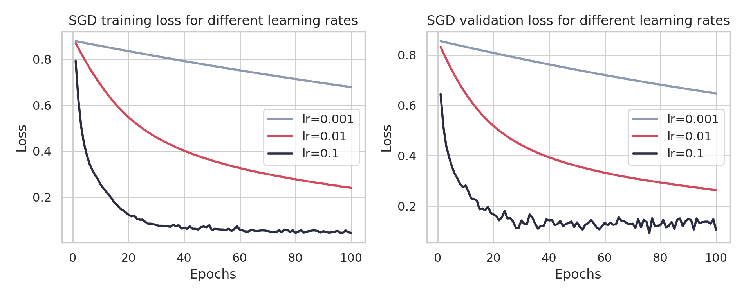
Figure 12: SGD training loss (left) and validation loss (right) for learning rates 0.001, 0.01 and 0.1.
Table 17: Effect of the SGD learning rate (Final Loss = training loss at epoch 100)
SGD Learning Rate | Final Loss | Test Accuracy | Observed Behavior
0.001 | 0.6793 | 0.7667 | Smooth but very slow decrease; training loss still 0.6793 after 100 epochs and never fell to 0.5
0.01 | 0.2401 | 0.8333 | Smooth, steady decrease; training loss reached 0.5 at epoch 25; still decreasing at epoch 100
0.1 | 0.0447 | 0.9333 | Fast decrease (loss ≤ 0.5 at epoch 4, ≤ 0.2 at epoch 14); after epoch 30 the validation loss fluctuated between 0.0935 and 0.1668; no divergence

Table 18: Additional metrics for the learning-rate experiment (epoch 100)
Learning rate | Train loss | Val loss | Train acc | Val acc | Test loss | Test acc
0.001 | 0.6793 | 0.6474 | 0.8229 | 0.7500 | 0.6895 | 0.7667
0.01 | 0.2401 | 0.2632 | 0.9167 | 0.8750 | 0.2965 | 0.8333
0.1 | 0.0447 | 0.1044 | 0.9896 | 0.9583 | 0.0906 | 0.9333

10.1 Observations
- Learning rate 0.001 (small): the loss decreased smoothly but very slowly. After 100 epochs the model was still far from a good solution (training loss 0.6793, test accuracy 76.67%). More epochs would be needed with this learning rate.
- Learning rate 0.01 (medium): this is the setting used in the main comparison. Training was smooth and steady, with a final training loss of 0.2401 and test accuracy of 83.33%; the loss was still decreasing at the end.
- Learning rate 0.1 (large): the loss fell much faster and reached the lowest final training loss (0.0447) and the highest test accuracy (93.33%) of the three. The validation loss was less smooth, with small up-and-down changes after the first 30 epochs, but the training did not become unstable or diverge for this learning rate on this problem.
The results show a strong effect of the learning rate on SGD: over this range, a larger learning rate gave faster training and better results within the fixed 100 epochs. This is a statement about this problem and this range of values. A learning rate that is too large can cause unstable training on other problems, and no value above 0.1 was tested here.
Important observation. SGD with learning rate 0.1 reached a test accuracy of 93.33% and a test loss of 0.0906. These are better than the values obtained by Adam with its default learning rate 0.001 in the main experiment (90.00% and 0.1716). This shows that the conclusions of Chapter 9 depend on the learning rates that were chosen. Adam was not tested with other learning rates in this project, so no conclusion is drawn about Adam with a tuned learning rate. The difference between 93.33 % and 90.00 % is one test sample out of 30.

CHAPTER 11 – ADVANTAGES AND LIMITATIONS

11.1 SGD Advantages
- Simple algorithm: the update rule, w ← w − ηg, is easy to understand and implement.
- Low computational overhead: it needs only the gradient, with no extra values stored for each parameter (unless momentum is added).
- Flexible learning-rate control: the learning rate and its schedule can be set directly by the user.
- Useful for many optimization problems: SGD and its variants are used in a very wide range of machine-learning problems.

11.2 SGD Limitations
- Learning-rate sensitivity: as Chapter 10 shows, results can change greatly with the learning rate.
- Potentially slower convergence: with a poorly chosen learning rate, or when gradients are small, progress can be slow.
- Noisy parameter updates: gradients estimated from mini-batches vary from step to step, so the path towards the minimum is not smooth.

11.3 Adam Advantages
- Adaptive step sizes: each parameter gets its own effective step size.
- Uses gradient history: the moving averages smooth the updates.
- Often convenient for neural-network training: reasonable results are frequently obtained with the default settings.
- Can work well with different parameter scales: parameters whose gradients differ greatly in size are handled by the normalisation.

11.4 Adam Limitations
- More computationally involved than basic SGD: each update needs extra calculations.
- Uses additional optimizer state: two extra values (m and v) are stored for every parameter, which increases memory use for large models.
- Still requires appropriate hyperparameter choices: the learning rate and the other settings can still matter.
- No guarantee of superiority: good performance on one dataset does not guarantee better performance everywhere.

CHAPTER 12 – APPLICATIONS
In every neural-network application, an optimizer is used to adjust the model parameters (weights and biases) during training so that the loss decreases. Some practical areas in which neural networks are trained with optimizers such as SGD, Adam and their variants are:
- Image classification: deciding what an image shows, for example identifying plant species or objects in photographs.
- Natural Language Processing (NLP): tasks such as text classification, translation, summarisation and question answering.
- Speech recognition: converting spoken audio into text for voice assistants and transcription tools.
- Time-series modelling: forecasting quantities that change over time, such as demand, energy consumption or sensor readings.
- Recommendation systems: predicting which products, videos or songs a user is likely to prefer.
- Computer vision: object detection, face recognition, medical image analysis and self-driving perception.
- Deep learning in general: training deep networks with many layers and millions of parameters, where the choice of optimizer and its settings can affect training time and quality.
The Iris classification in this project is a small example of the same principle: the optimizer is the part of the training procedure that turns the gradients calculated by backpropagation into actual changes of the network parameters.

CHAPTER 13 – RESULT
The findings below are for the Iris dataset and the experimental setup of this project (4–16–8–3 network, 96 / 24 / 30 split, batch size 16, 100 epochs, SGD with learning rate 0.01 and Adam with learning rate 0.001, same initial weights).
Table 19: Summary of experimental results
Quantity | SGD (lr 0.01) | Adam (lr 0.001)
Test accuracy | 0.8333 (83.33%) | 0.9000 (90.00%)
Test loss | 0.2965 | 0.1716
Final training loss | 0.2401 | 0.1012
Final validation loss | 0.2632 | 0.1919
Final training accuracy | 0.9167 | 0.9583
Final validation accuracy | 0.8750 | 0.9167
Macro precision / recall / F1 | 0.8498 / 0.8333 / 0.8295 | 0.9024 / 0.9000 / 0.8997
Epoch at which training loss first ≤ 0.5 | 25 | 17
Epoch at which training loss first ≤ 0.2 | not reached | 62
Test samples misclassified | 5 of 30 | 3 of 30

Findings for this experiment:
- The network learned to classify the Iris flowers with both optimizers. Both models classified all Setosa test flowers correctly; all errors were between Versicolor and Virginica.
- Adam reduced the training and validation losses faster, and its final losses were lower than those of SGD with its default learning rate.
- Adam obtained 90.00% test accuracy and SGD 83.33%; the macro F1-scores were 0.8997 and 0.8295.
- Neither optimizer had completely converged after 100 epochs; both losses were still decreasing.
- In the learning-rate experiment, SGD with a learning rate of 0.1 reached a test accuracy of 93.33% and a final training loss of 0.0447, whereas 0.001 reached 76.67%; the learning rate strongly affected SGD.
- Over 10 repeated runs, the mean test accuracy was 91.00% for Adam and 81.67% for SGD (default learning rates), with noticeable run-to-run variation.
Scope of the findings. These findings are specific to the Iris dataset and this experimental setup. They do not show that Adam is always better than SGD, or the reverse. Optimizer performance depends on the dataset, the architecture, the hyperparameters and the training setup.

CHAPTER 14 – CONCLUSION
In this project, a small fully connected neural network was built to classify Iris flowers into three species. The Iris data were loaded from scikit-learn, divided into training (96), validation (24) and test (30) sets with a fixed random seed, and the four input features were standardised using statistics from the training data only. The network had two hidden layers with 16 and 8 ReLU neurons and a three-neuron Softmax output layer, and it was trained with sparse categorical cross-entropy loss.
The same network was trained twice from identical initial weights: once with SGD (learning rate 0.01) and once with Adam (learning rate 0.001), using the same data, batch size (16) and number of epochs (100). The loss and accuracy on the training and validation sets were recorded for every epoch, and the final models were evaluated on the test set using accuracy, confusion matrices and classification reports.
In this experiment, the training and validation losses of both optimizers decreased smoothly, and the accuracies increased. Adam’s losses decreased faster and reached lower values (final training loss 0.1012 against 0.2401), and Adam reached a test accuracy of 90.00% compared with 83.33% for SGD. Both models identified every Setosa flower correctly, and the remaining errors were between Versicolor and Virginica. A supplementary experiment showed that SGD is sensitive to the learning rate: with a learning rate of 0.1 it reached 93.33% test accuracy, while with 0.001 it learned very slowly. Repeated runs showed that results vary from run to run, which is expected with a very small test set.
The project demonstrates that an optimizer is the component that turns gradients into parameter updates, and that both the choice of optimizer and its hyperparameters, especially the learning rate, can strongly influence how quickly and how well a network trains. The main lesson is that optimizers should be compared under clearly stated and fair conditions, that single-run differences on a small test set should be interpreted with caution, and that the findings of one experiment should not be generalised to all datasets or models.

CHAPTER 15 – FUTURE ENHANCEMENTS
- Test additional optimizers, such as RMSprop and Adagrad, and SGD with momentum.
- Use a larger dataset, for example a larger tabular dataset, so that the test results are less affected by a few samples.
- Experiment with deeper neural networks to see how the optimizers behave when more layers are used.
- Perform systematic hyperparameter tuning, for example a grid or random search over the learning rate of both SGD and Adam (Adam’s learning rate was not varied in this project).
- Compare different batch sizes, since the batch size changes the noise of the gradient estimate.
- Add dropout and regularisation to study overfitting and generalisation.
- Train for more epochs or use early stopping, because neither optimizer had fully converged after 100 epochs.
- Use cross-validation or many random splits for more reliable accuracy estimates.
- Apply the optimizers to image or text classification, to examine whether the observations change for larger and more complex problems.

CHAPTER 16 – VIVA QUESTIONS AND ANSWERS
Q1. What is a neural network?
Ans. A neural network is a machine-learning model made of layers of connected neurons. Each neuron computes a weighted sum of its inputs, adds a bias and applies an activation function. By learning the weights and biases from data, the network can map inputs (such as flower measurements) to outputs (such as flower species).
Q2. What is an optimizer?
Ans. An optimizer is an algorithm that updates the weights and biases of a model during training, using the gradients of the loss, so that the loss becomes smaller. Examples are SGD, RMSprop and Adam.
Q3. What is SGD?
Ans. Stochastic Gradient Descent updates the parameters using the gradient calculated on a single sample or a small mini-batch: w ← w − η · g, where η is the learning rate and g is the gradient. It is simple and cheap, but its updates are noisy and it depends on the learning rate.
Q4. What is Adam?
Ans. Adam (Adaptive Moment Estimation) is an optimizer that keeps a moving average of the gradients (first moment) and of the squared gradients (second moment) and uses them to give each parameter its own adaptive step size. It combines momentum-like smoothing with adaptive learning rates.
Q5. What is the difference between SGD and Adam?
Ans. Basic SGD uses one learning rate for all parameters and the update is proportional to the current gradient. Adam keeps additional information about past gradients and adapts the step size of each parameter. Adam is therefore more adaptive but also more computationally involved and uses more memory.
Q6. What is a learning rate?
Ans. The learning rate is a hyperparameter that controls how large a step the optimizer takes in each update. If it is too small, training is slow; if it is too large, training can become unstable.
Q7. What is a loss function?
Ans. A loss function measures how different the model’s predictions are from the true values. Training tries to make the loss as small as possible. In this project the loss is sparse categorical cross-entropy.
Q8. Why is cross-entropy used for classification?
Ans. Cross-entropy compares the predicted probability distribution with the true class. It gives a small loss when the correct class is given a high probability and a large loss when it is given a low probability, and it works well with Softmax outputs. The sparse version accepts integer class labels directly.
Q9. What is backpropagation?
Ans. Backpropagation is the method used to compute the gradient of the loss with respect to every weight and bias, by applying the chain rule backwards from the output layer to the input layer. The optimizer then uses these gradients to update the parameters.
Q10. What is an epoch?
Ans. An epoch is one complete pass of the training algorithm through the whole training dataset. In this project, training for 100 epochs means that each training sample was used 100 times.
Q11. What is a batch size?
Ans. The batch size is the number of training samples used to calculate one gradient and perform one parameter update. Here the batch size is 16, so with 96 training samples there are 6 updates per epoch.
Q12. What is ReLU?
Ans. ReLU (Rectified Linear Unit) is an activation function defined as f(z) = max(0, z). It outputs zero for negative inputs and the input itself for positive inputs. It is simple, cheap to compute and widely used in hidden layers.
Q13. Why is Softmax used in the output layer?
Ans. Softmax converts the raw output scores into probabilities between 0 and 1 that add up to 1. This makes the outputs interpretable as class probabilities for multiclass classification and matches what the cross-entropy loss expects.
Q14. What is overfitting?
Ans. Overfitting happens when a model learns the training data too closely, including its noise, so that it performs well on the training data but poorly on new data. A typical sign is that the training loss keeps decreasing while the validation loss starts to increase.
Q15. What is a confusion matrix?
Ans. A confusion matrix is a table that compares true classes (rows) with predicted classes (columns). The diagonal shows correct predictions and the off-diagonal entries show which classes are confused with each other.
Q16. What are precision and recall?
Ans. Precision is the fraction of samples predicted as a class that truly belong to it. Recall is the fraction of samples of a class that were correctly found. The F1-score is their harmonic mean.
Q17. Why should both optimizers use the same experimental conditions?
Ans. To make the comparison fair. If the architecture, initial weights, data split, preprocessing, batch size and number of epochs differed, we could not tell whether a difference in the results was caused by the optimizer or by the other changes. Keeping everything else the same isolates the effect of the optimizer (and its learning rate).
Q18. Does Adam always outperform SGD?
Ans. No. Optimizer performance depends on the dataset, the model architecture, the hyperparameters (especially the learning rate) and the training setup. In this project Adam with its default learning rate did better than SGD with its default learning rate, but SGD with a learning rate of 0.1 did as well or better on the test set, so the result depends on the settings and cannot be generalised.

CHAPTER 17 – REFERENCES
Documentation
[1] TensorFlow Developers. TensorFlow documentation. https://www.tensorflow.org/
[2] Keras documentation: SGD optimizer. https://keras.io/api/optimizers/sgd/
[3] Keras documentation: Adam optimizer. https://keras.io/api/optimizers/adam/
[4] Scikit-learn documentation. https://scikit-learn.org/stable/
[5] NumPy documentation. https://numpy.org/doc/
[6] Matplotlib documentation. https://matplotlib.org/stable/
[7] UCI Machine Learning Repository: Iris dataset. https://archive.ics.uci.edu/dataset/53/iris
Research papers
[8] Kingma, D. P., & Ba, J. (2015). Adam: A Method for Stochastic Optimization. International Conference on Learning Representations (ICLR). arXiv:1412.6980.
[9] Robbins, H., & Monro, S. (1951). A Stochastic Approximation Method. The Annals of Mathematical Statistics, 22(3), 400–407.
[10] Rumelhart, D. E., Hinton, G. E., & Williams, R. J. (1986). Learning representations by back-propagating errors. Nature, 323, 533–536.
[11] Fisher, R. A. (1936). The use of multiple measurements in taxonomic problems. Annals of Eugenics, 7(2), 179–188.
[12] Ruder, S. (2016). An overview of gradient descent optimization algorithms. arXiv:1609.04747.
[13] Pedregosa, F., et al. (2011). Scikit-learn: Machine Learning in Python. Journal of Machine Learning Research, 12, 2825–2830.
[14] Harris, C. R., et al. (2020). Array programming with NumPy. Nature, 585, 357–362.
[15] Hunter, J. D. (2007). Matplotlib: A 2D graphics environment. Computing in Science & Engineering, 9(3), 90–95.
[16] Abadi, M., et al. (2016). TensorFlow: A system for large-scale machine learning. 12th USENIX Symposium on Operating Systems Design and Implementation (OSDI ’16), 265–283.
Books
[17] Goodfellow, I., Bengio, Y., & Courville, A. (2016). Deep Learning. MIT Press.
[18] Géron, A. (2022). Hands-On Machine Learning with Scikit-Learn, Keras, and TensorFlow (3rd ed.). O’Reilly Media.
[19] Bishop, C. M. (2006). Pattern Recognition and Machine Learning. Springer.

